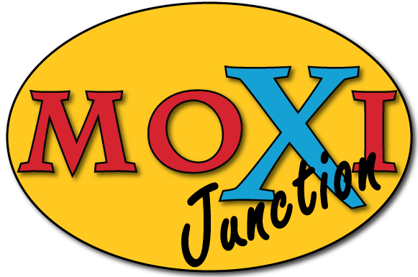 Rental Policy

MOXI Junction’s mission is to provide job training and employment to special needs young adults through specialty coffee, fresh baked goods, and art consignment.

Reservation: During business hours, individual table reservations may be made at no charge at the management’s discretion depending on availability.

Business Hours Rental: During business hours the entire upstairs can be rented. There is a $25 rental fee plus $100 minimum in MOXI food and drink OR $125 per hour if no food or drink is purchased. The $25 rental fee is required in advance to hold the room

After Hours Rental: The coffeehouse can be rented out after hours for $250 with a 3 hour minimum. Each additional hour after the first two is $50. $100 due at booking remainder due one week prior to event. The deposit will not be refunded if canceled within 72 hours. Rental is limited to customer areas only and time frame must include set up and clean up. Food and drink by MOXI can be arranged.

Name: _______________________________________________________

Business:_____________________________________________________

Street Address:_________________________________________________

City ________________________ State__________ Zip:_____________

Phone: ___________________

Email: ___________________________________________________

Date requested for private rental:____________ Time: _________ AM PM

Approximate number of people expected at your event:______________

How did you hear about Moxi Junction?______________________________

I understand that I am responsible for the facility during our private use of MOXI Junction, leaving it in the same condition in which we found it.

Signature__________________________________ Date______________

Please submit requests to: MOXI Junction or email Joanna@MOXIJunction.com

319 S. Park Maize, KS 67101 316-260-4000

